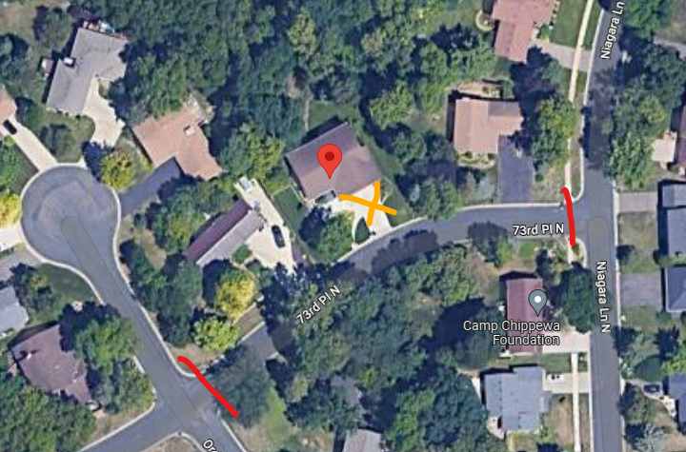

Red = Road Closure Signs
Orange = 60 Ton Crane Set Up On Driveway.

