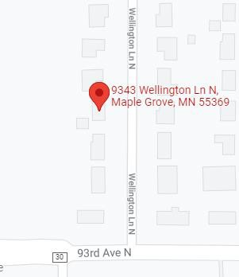

Length of sewer line is 67 feet Dig depth 8 to 10.5 feet

Hero will excavate from foundation of home out to roughly 50 foot mark. This will allow us to achieve 1/4 per foot or greater for code of properly pitched line. Dirt will be piled on right and left side of yard along with part of road. - We will replace pipe with schedule 40 pvc. - since we have a open pit we will use Picote machine and de scale interior cast iron and the remaining 10 feet under the road. -After pipe is replaced and re pitched it will be inspected by city inspector Hero will then backfill and re compact yard to near original soil depth.

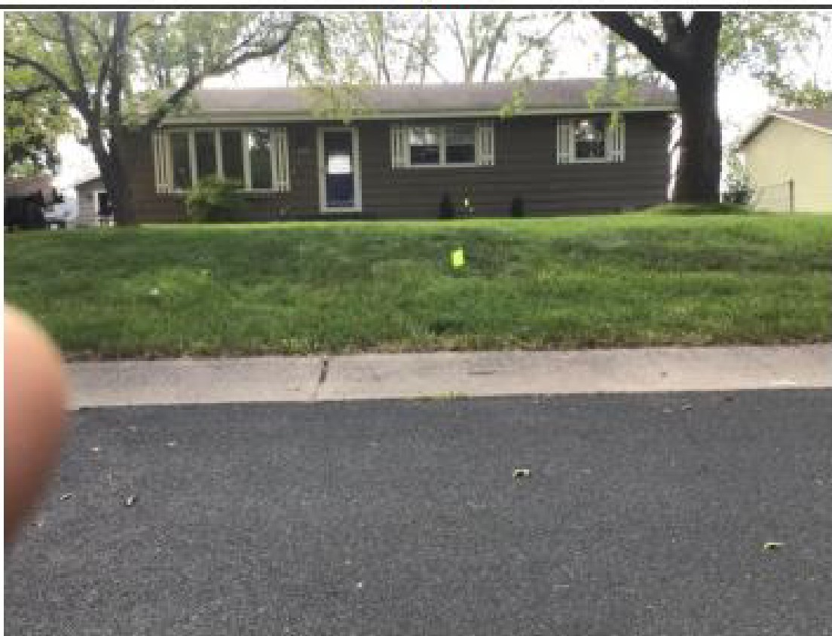

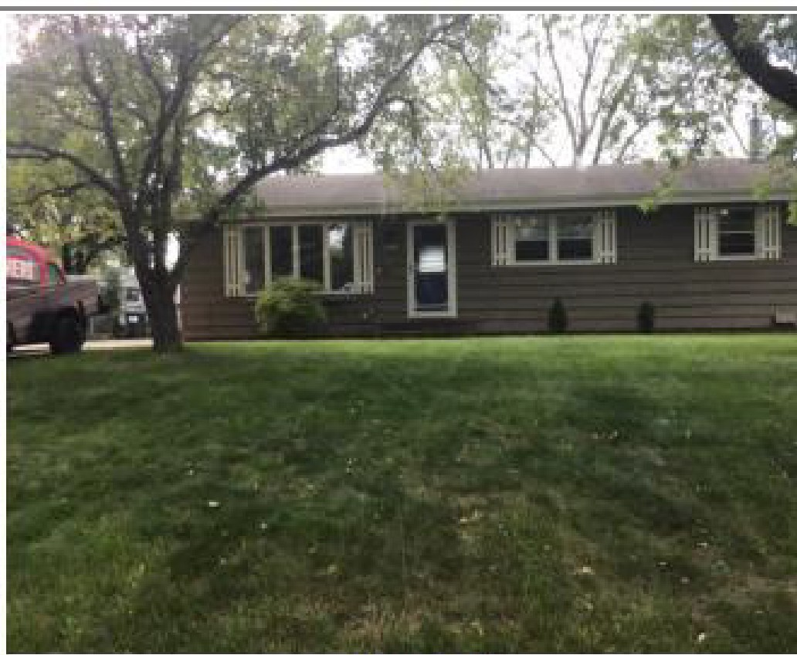

-



Fmnt yard

Proposed dig locatfon

**i--rontyara**